Create VCN

1. Login to OCI
2. Navigate to Networking -> VCN (Virtual Cloud Network)
3. Click to Start VCN Wizard -> Select Create VCN with internet connectivity.

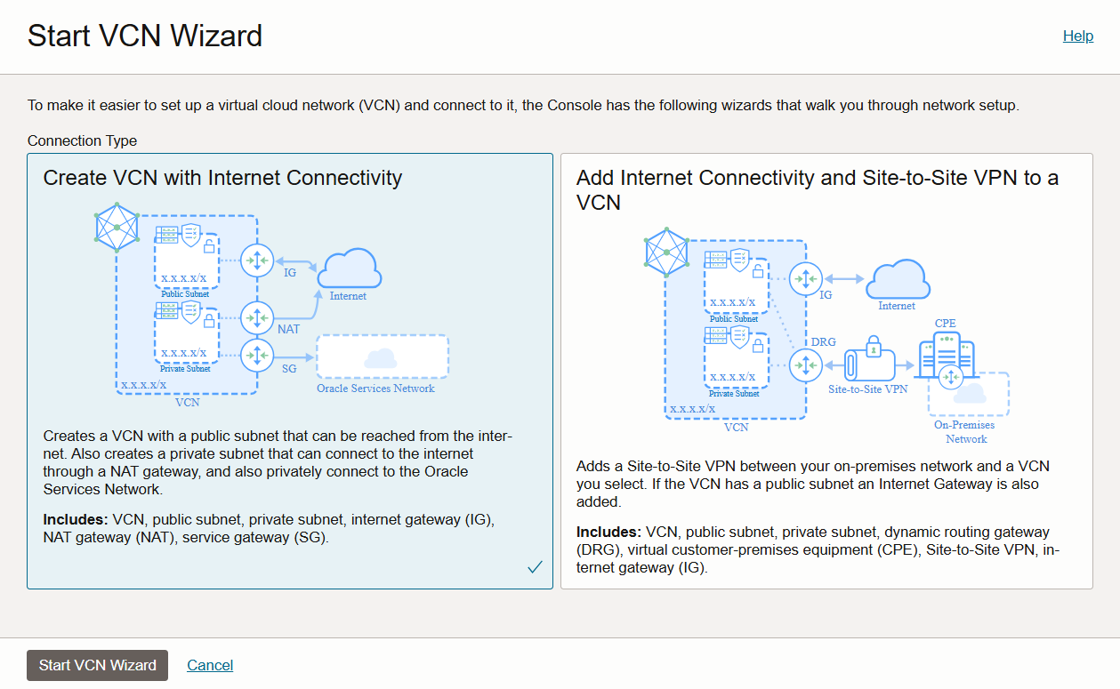

1. Write information like name of VCN and select Compartment

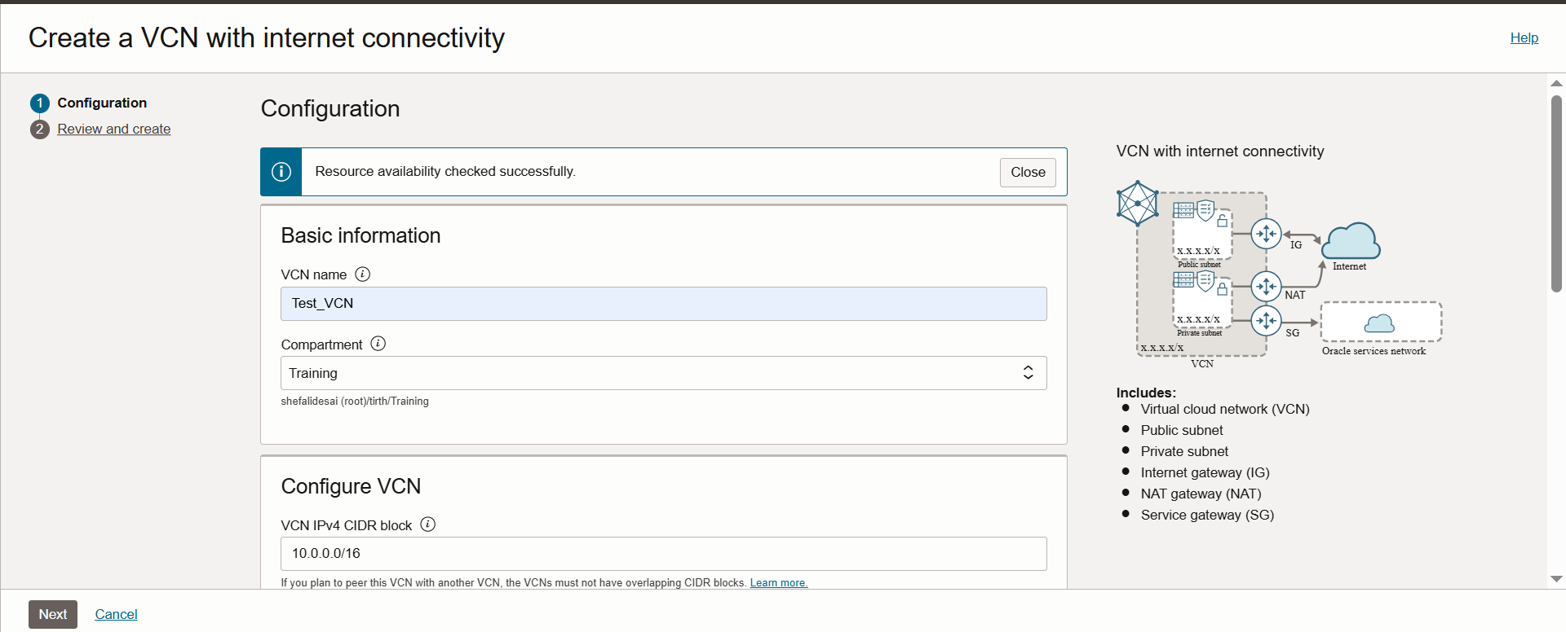

1. Keep rest all by default it will take everything automatically

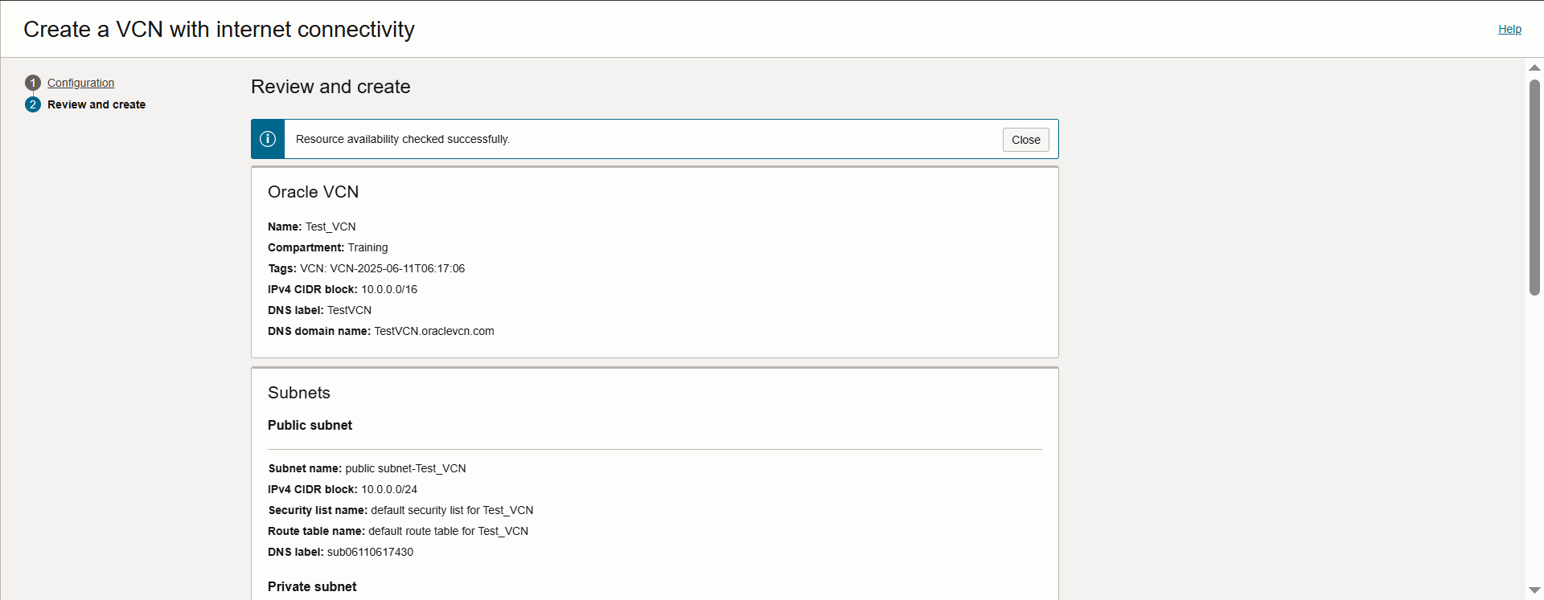

1. Click create VCN -> VCN Created

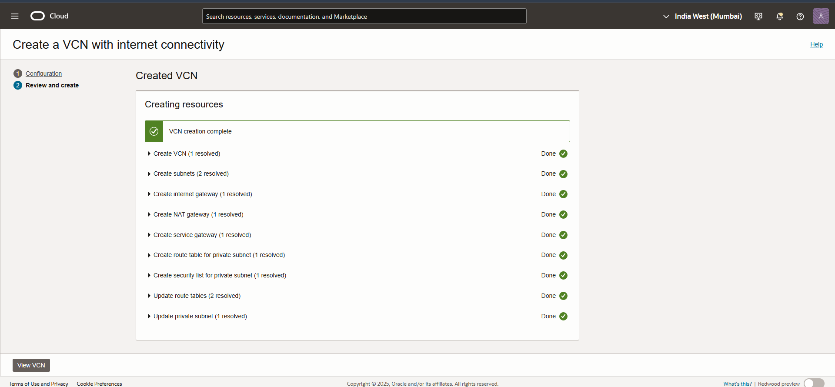

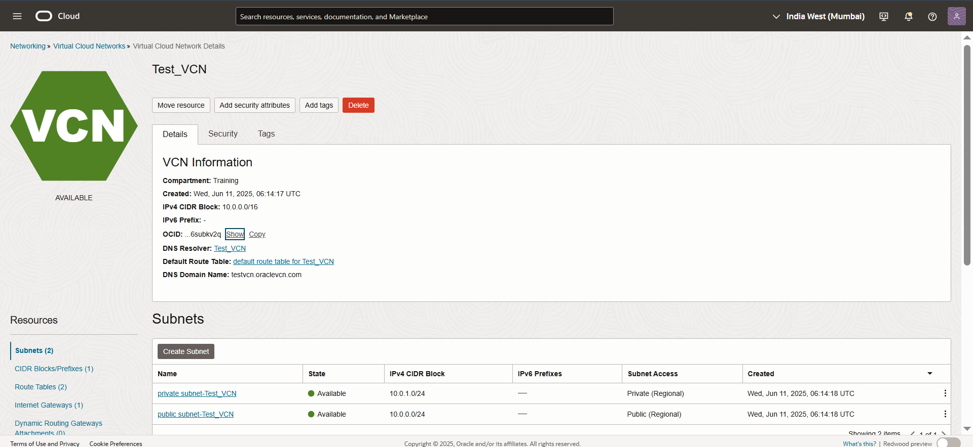

Create VM

1. Navigate to Compute -> Instance -> Select Compartment

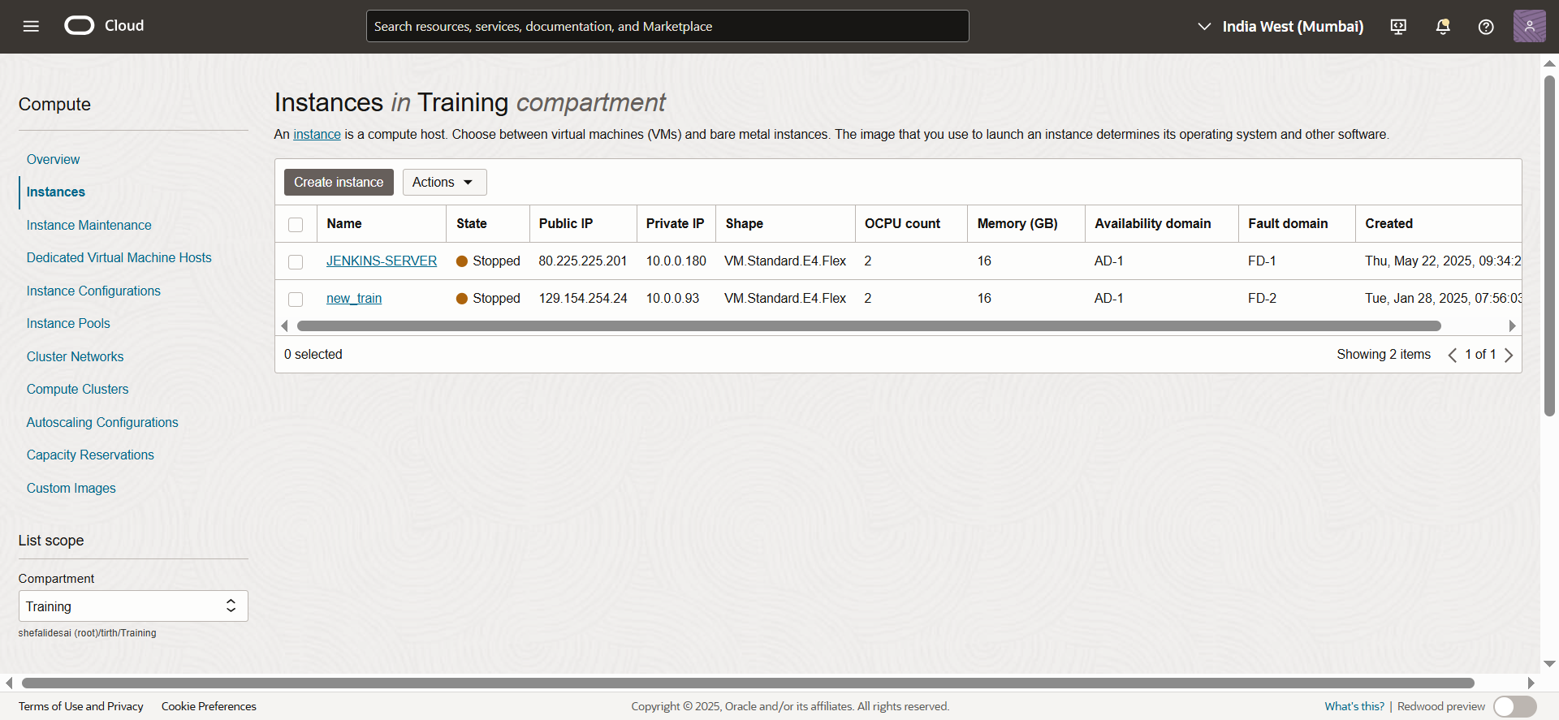

1. Click create instance -> give information like name -> select compartment

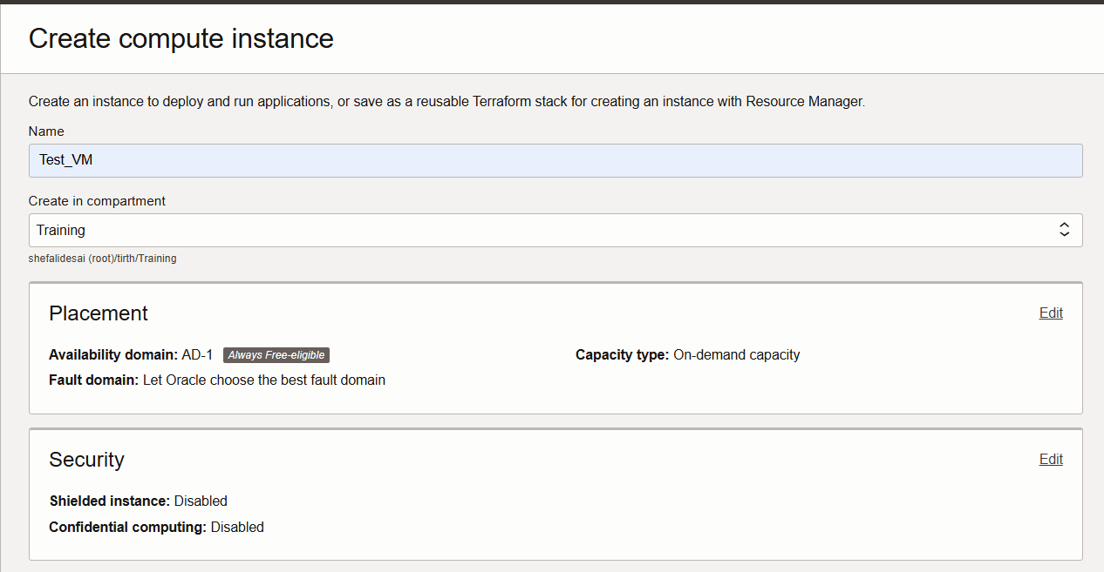

1. Select image and shape

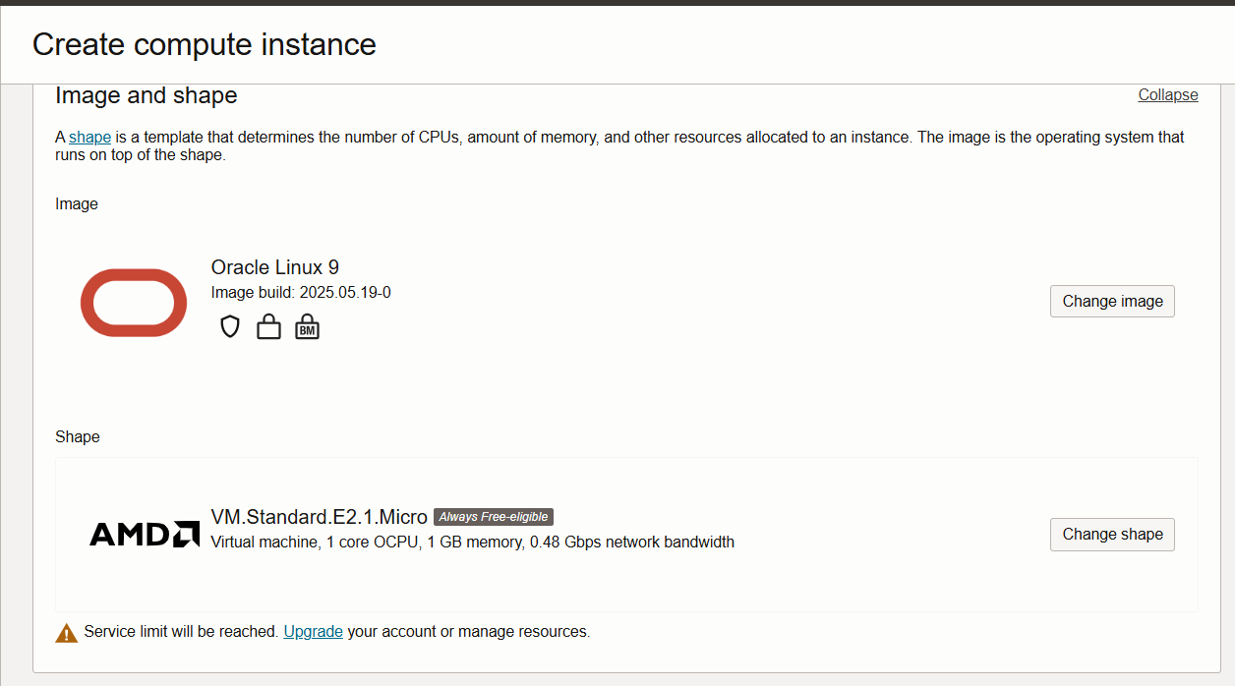

1. Download private and public key

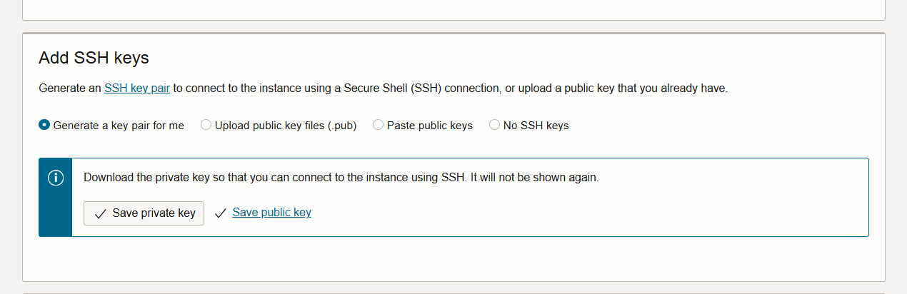

1. Click create instance -> instance created

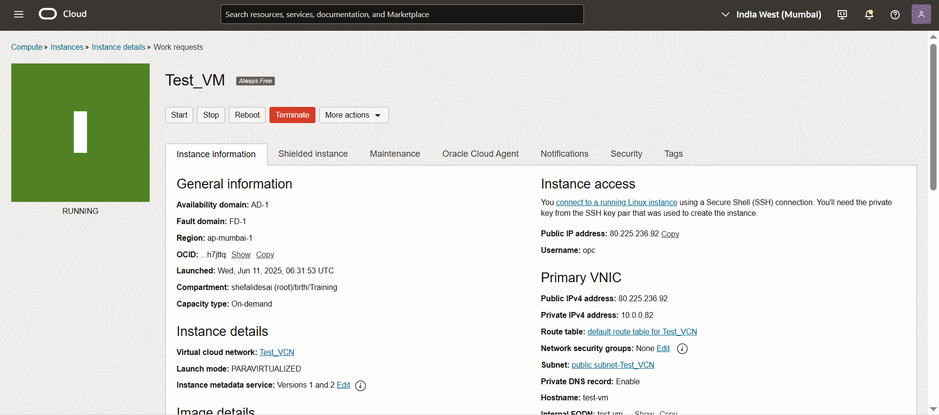

* Open puttygen
* Upload downloaded private key and generate new private key
* Save the private key and remember the name and location
* Open putty
* Copy paste the public ip of the VM
* + to SSH
* + Auth
* Credential
* Add generated private key
* Login with the username ‘opc’
* Login successful
* Test the working by running commands like
  + If config
  + ip a
  + curl
  + ping google , etc..

